Name: _______________________________________ Date: _____________
Group Members
_____________________________ ____________________________

_____________________________ ____________________________

Supplies: Graph paper, rulers, plastic table cloths, wooden dowels, string yarn, wood snipper, scissors, glue, duct tape, markers,
PART 1
- For this project you will design a kite using wood dowels and a tablecloth
- Design a kite on the graph paper on the next page. Use your measurements from your graph paper to cut the wood dowels.
- Connect the wood dowels using duct tape.
- Cut your tablecloth to fit your kite and attach it to the wood dowels using duct tape.
- Attach a kite string.

Part 2
- You will now have to fly your kite.
  - One person will be in charge of flying the kite
  - One person will have to stand underneath the kite (see below)
  - One person will be in charge of using a measuring tape to measure the distance between the person flying the kite and the person standing under the kite. Measure to the nearest inch.
  - Once this distance is measured and recorded, on the accompanying sheet, the person flying the kite will have to carefully pull the kite down without changing the length of the string. The string will have to be measured to the nearest inch and recorded on the accompanying sheet.

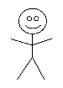
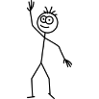

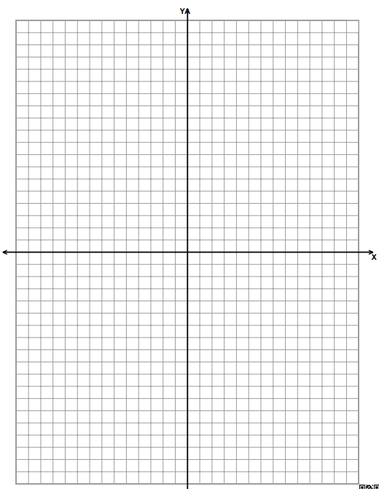

RECORD YOUR MEASUREMENTS ON THIS SHEET
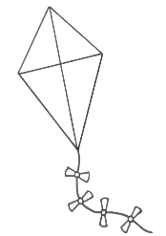

PART 3
- Using your measurements and knowledge of trigonometry, find the angle of elevation from the ground to the kite. All work should be shown below.

- Using your measurements and knowledge of right triangles, find the last remaining side of your triangle (the height of the kite).

Part 4
- Now you will decorate your kite with review material from the beginning of the school year. See below.
Coordinate Geometry Formulas
-Distance
-Midpoint
-Slope
Angle Rules
-Angles of a triangle
-Complementary
-Supplementary
-Sum of interior
-Sum of exterior
-Each interior
-Each exterior

Transformations Rules
Locus Rules
 | 5 | 3 | 1
Kite | The kite is well constructed and it can be seen that a great deal of effort was put into the construction | The kite is well constructed and it can be seen that some effort was put into the construction | The kite is not well constructed
Measurements | Appropriate measurements were recorded for ground distance and string length. | Measurements did not seem appropriate. | Measurements were not taken.
Angle | All work was correct in calculating the angle of elevation and the third side of the triangle. | A mistake was made in calculating the angle of elevation or in finding the third side of the triangle. | More than one mistake was made  Or  Angle of elevation/side were not found.
Creativity | Kite was colorful and decorated with all review facts. | Kite was not colorful  Or  Was missing a fact or two | Kite was missing more than two facts.

